Vimarsha Rathnayake - 1823241
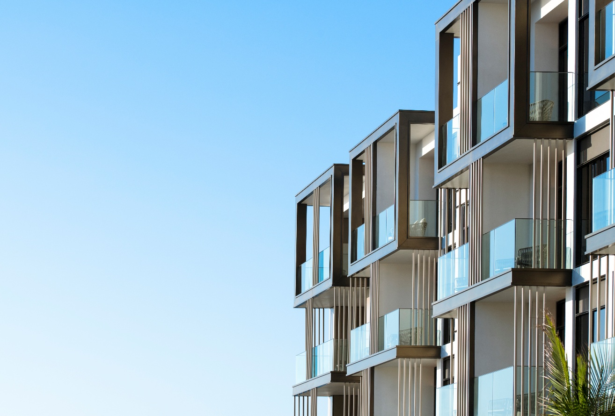
Kaplan Business School T2 2025
Capstone DATA6000
"Australia’s Next Residential Property Hotspots”
Individual Report

Table of Contents

Executive Summary 3
1.0 Industry Problem 4
1.1 Industry background 4
1.2 Research problem identification 4
1.3 research question 5
1.4 Significance of the study 5
2.0 Data processing and management 5
2.1 Data collection and exploration 5
2.2 Use of descriptive and predictive analytics 6
2.3 Data pre-processing 6
3.0 Data Analytics Methodology 8
4.0 Visualisation and Evaluation of Results 9
4.1 ARIMA model 9
4.2 Random Forest model 11
5.0 Recommendations 13
6.0 Data Ethics and Security 14
7.0 References 15
Appendix 16

List of Figures

Figure 1: Median price of residential dwellings in from 2002 to 2024 4
Figure 2: Variables of the Median Residential Property prices dataset 7
Figure 3: Variables of the CPI All groups dataset 7
Figure 4 : Median housing price actual and forecasted values 9
Figure 5: ARIMA city wise forecast 10
Figure 6: Actual vs predicted scatter plot 11
Figure 7: CPI vs Median Price dependency plot 12
Figure 8: Median price vs City dependency plot 12

List of Tables
Table 1: Results comparison of ARIMA model 9
Table 2: Random Forest model evaluation 11

Executive Summary

Having accurate forecasts of residential property prices is important to balance the supply and demand of housing, better resource allocation, urban planning and policy development. With record high migrants, supply shortages and affordability concerns, the real estate stakeholders are unable to identify the property price trends across different states in Australia. The focus of this study is to forecast which Australian capital city/state will experience the highest growth in residential property prices over the next 3 years. To estimate the property prices, a combination of ARIMA and Random Forest analytics techniques has been used. The results suggest that some cities remain be the expensive markets while some are emerging with projected percentage growth. The analysis highlights investment opportunities and affordability challenges.

1.0 Industry Problem

1.1 Industry background

The Real Estate industry in Australia plays a crucial role towards the national economy, contributing substantially for household wealth, construction, employment and state revenue (Abelson and Joyeux, 2023). As shown in Figure 1, pre pandemic property prices has experienced steady growth across capital cities. Over the past 20 years, Sydney has been the most expensive property market followed by Melbourne. In contrast, markets like Darwin and Perth shows a slower growth (Vescovi, Weiss Sidi and Friedmann, 2022). According to Yanotti et al., (2024), the pandemic has changed these market patterns and created a boom in housing demand across both regional and metropolitan markets. However, interest rate hikes from year 2022, slow down the price growth in residential property markets (Abelson and Joyeux, 2023).
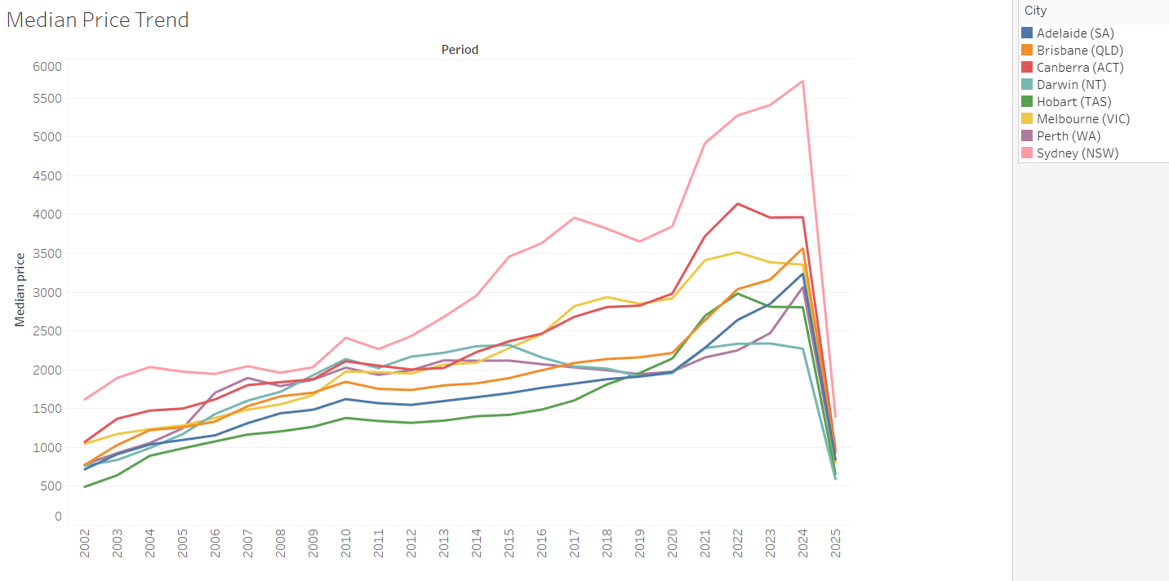
Figure 1: Median price of residential dwellings in from 2002 to 2024

1.2 Research problem identification

Over the recent years, the sector has been exposed to affordability issues due to various external factors. According to Soltani and Chyi Lin Lee, (2024) residential property prices are most influenced by population growth, interest rates, employment levels and supply of housing stocks. The demand for housing has been concentrated mainly on capital cities where labour markets and infrastructure availability attracts new residents compared to other regional areas in the country. These issues have result in uncertainty among the stakeholders about the markets with potential growth opportunities.

1.3 research question

The key research question of this study is “Which capital city or state is likely to have the highest residential property price growth over the next three years”.

1.4 Significance of the study

The main goal of this study is to forecast which capital city or state is likely to have the highest residential property price growth over the next three years. This will help to obtain information to various stakeholders such as investors, real estate agents and government planners to make informed decisions. Accurate forecast in property prices, provide opportunities for investors to maximise their returns and to manage portfolio risks, help real estate agents to do market positioning, resource allocation and informed client advisory. It also helps policy makers to effectively manage housing supply, infrastructure planning, policy development and economic stability.

2.0 Data processing and management

2.1 Data collection and exploration

In the development of the model, data have been obtained by Australian Bureau of Statistics (ABS) which is publicly available and a reputable source. Before constructing the model, exploratory data analysis was conducted to uncover the underlying data trends. It helps to understand the features present in the data set and purpose (Adetunji et al., 2022). Two key datasets from ABS were used for this study. First dataset is the Median Residential Property prices reported quarterly for the eight Australian cities. This dataset captures the central tendency of house prices and allows to make comparisons of market performance across different Australian cities. Second dataset, Consumer Price Index (CPI) of all groups Australia wide reported quarterly, is used as an economic predictor to show the impact of inflation towards housing affordability and price growth. Both datasets spans from year 2002 to 2025 consisting of 60-80 quarters of data. This data of over 20 years can capture both long term trend and short-term cycles including the pre pandemic boom and post COVID fluctuations.
Data source links –
https://www.abs.gov.au/statistics/economy/price-indexes-and-inflation/total-value-dwellings/latest-release
https://www.abs.gov.au/statistics/economy/price-indexes-and-inflation/consumer-price-index-australia/latest-release
https://github.com/vimurathnayake-90/DATA6000

2.2 Use of descriptive and predictive analytics

Descriptive analytics is used to explore the historical house prices and inflationary movements. As shown in Figure 1, time series visualisations are used to identify the cyclical behaviour of different cities. Sydney and Melbourne consistently lead in the Median property prices compared to cities such as Adelaide and Hobart. Predictive analytics is used to address the research question using time series models and machine learning models which can provide a more flexible approach to capture non-linear relationships between predictors.

2.3 Data pre-processing

Data pre-processing was done to clean the raw data extracted from ABS to make it suitable for model development. As shown in Figure 2 and 3 the initial dataset of median residential property prices and CPI all group had many variables. Only the relevant variables – date, median dwelling prices for each city and CPI all group for each city was extracted from the original data sets. Figure 3 shows some key columns that are related to the predictor variable in the pre-processed dataset.
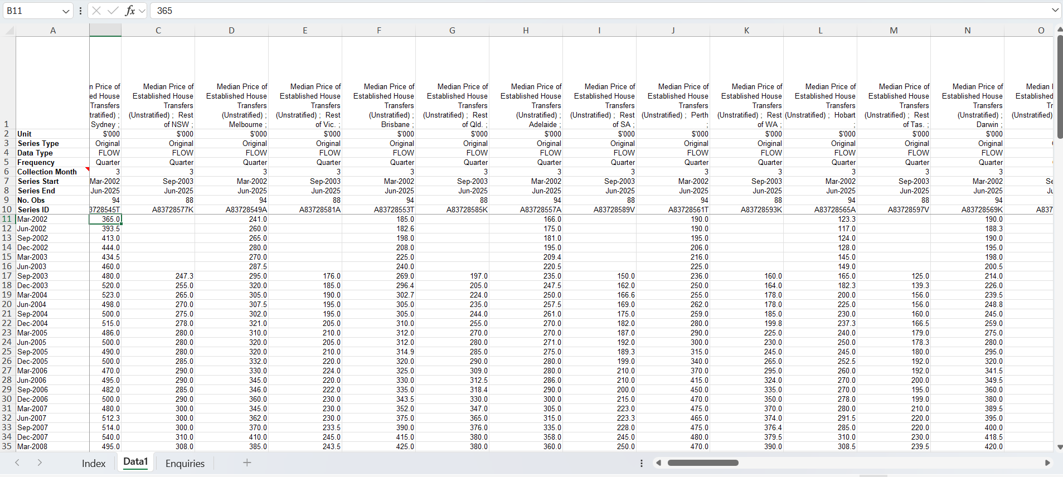

Figure 2: Variables of the Median Residential Property prices dataset
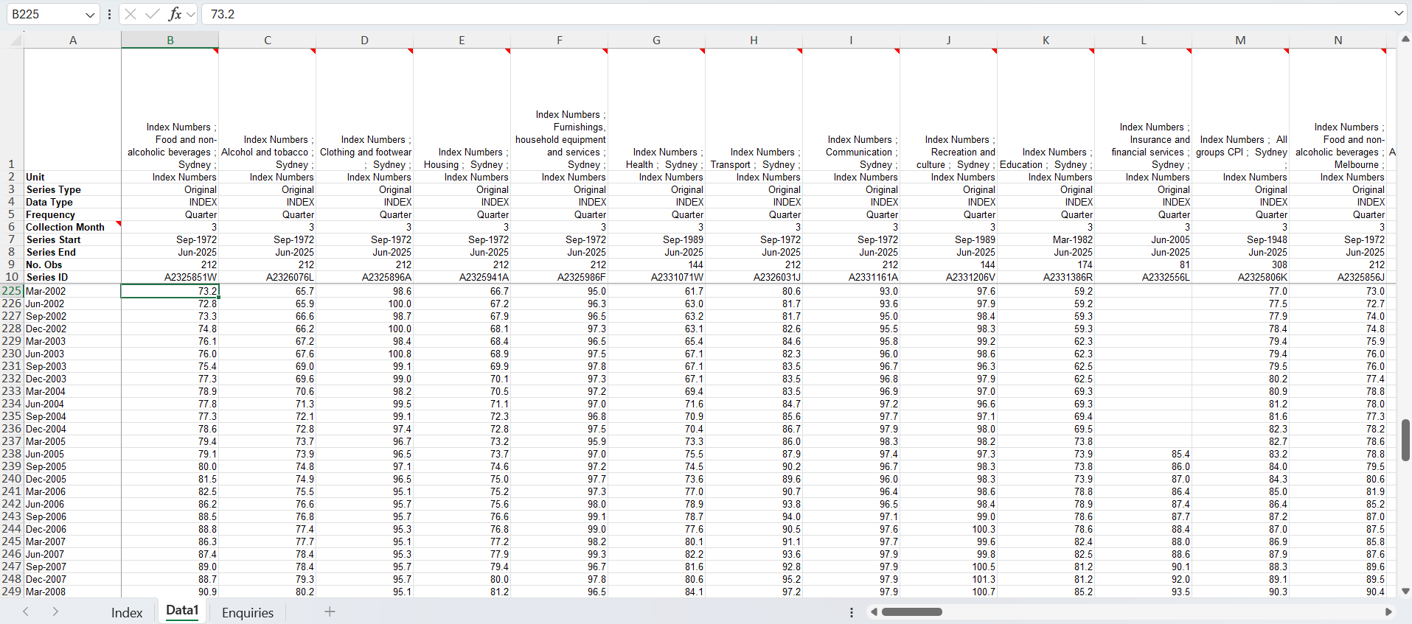

Figure 3: Variables of the CPI All groups dataset
The structure and the consistency of data were checked to ensure similar time intervals. No null values or extreme outliers were examined in the dataset. To prepare the dataset for time series modelling, the original wide format was converted to long format by unpivoting the city column. Earlier the dataset consisted of eight separate columns for the eight major cities. The final dataset consists of 744 rows of quarterly observations across eight cites. This dataset was then exported to Exploratory software to run the ARIMA and Random Forest regression.

3.0 Data Analytics Methodology

The research applies two analytical methodologies that integrates time series forecasting using ARIMA (Auto Regressive Integrated Moving Average) and Machine learning model using Random Forest regression. The rationale for this mix methodologies is to capture both temporal dynamics of housing prices and the nonlinear relationship between housing prices and economic indicators such as CPI.
ARIMA is one of the liner time series models widely used in time series forecasting. ARIMA models explains the variability in the series by past period effects and randomness. It captures temporal trends and work well with quarterly data. ARIMA model consist of three main processors: diagnostic check, identification and prediction (Temür, Akgün and Temür, 2019). It explains for trends, cycles and autocorrelations within the data by joining autoregressive (AR), differencing (I) and moving average (MA). This makes ARIMA effective in predicting near future housing prices based on the historical price patterns from year 2002 to 2025. With the fluctuating nature of the housing market, ARIMA is a suitable methodology to capture systematic patterns.
However, classical methods such as ARIMA are not sufficient to capture high nonlinearity. Therefore, machine learning method Random Forest regression has been incorporated for the research. It is a popular machine learning technique which has both supervised classification and regression. Rather than depending on a single decision tree, Random Forest builds multiple decisions trees and aggregate their predictions to increase accuracy. It also robust to noise and helps to identify which feature influence strongly on housing prices. This will allow the model to separately learn how each city’s property market behave.
The dual use of statistical hybrid forecasting (ARIMA) and supervised machine learning (Random Forest) provides a more holistic methodological framework. ARIMA is excellent in capturing historical trends at city level while Random Forest enhances predictive power incorporating external drivers like CPI which plays a crucial role in housing affordability. By comparing the outputs of both methods, based on separate liner and non-liner components of timeseries, the study confirms accuracy and confidence to identify which Australian capital city is likely to experience the highest residential property price growth.

4.0 Visualisation and Evaluation of Results

4.1 ARIMA model

Three different ARIMA (p,d,q) models were performed on median house price data, and the best fit was selected using statistical criteria AIC and BIC. The results of the model error comparisons are given in Table 1. According to the results, the model with lowest error values is the most accurate model for forecasting. The most accurate model among the three is the model of ARIMA (0,1,3).
ARIMA (p,d,q) | RMSE | MAE | MAPE (Ratio) | R Squared | AIC | BIC
0,1,3 | 11.3932038 | 8.81638262 | 0.0169028 | 0.99583224 | 728.059505 | 743.190237
1,1,1 | 12.5575593 | 9.67931389 | 0.01838635 | 0.99493684 | 742.207301 | 754.816244
1,1,2 | 11.9487926 | 9.48304508 | 0.01828427 | 0.99541585 | 733.990716 | 749.121447

Table 1: Results comparison of ARIMA model

Figure 4 reveals, the relative graph of median housing price actual and forecasted values obtained with ARIMA model (0,1,3).
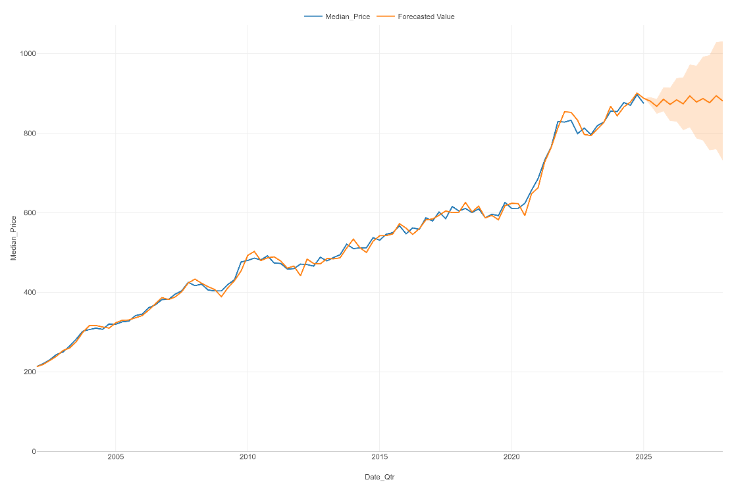
Figure 4 : Median housing price actual and forecasted values
When the Figure 4 is analysed, actual and forecasted values are overlapping each other showing an excellent fit with less errors. The model produces values close to the actual data with RMSE value of 11.3932, MAE 8.8 and MAPE 0.016 where the forecast is around 1.7% off the actual prices.
ARIMA city wise forecast is shown in Figure 5, indicating a sustained upward trend in most of the cities. By the next three years, median residential property price in Sydney is expected to reach approximately AUD 1.55 million, continue to be the most expensive market, followed by Canberra AUD 1.11 million. However, a strong growth is also seen in markets like Brisbane, Adelaide and Perth showing a faster percentage of growth.

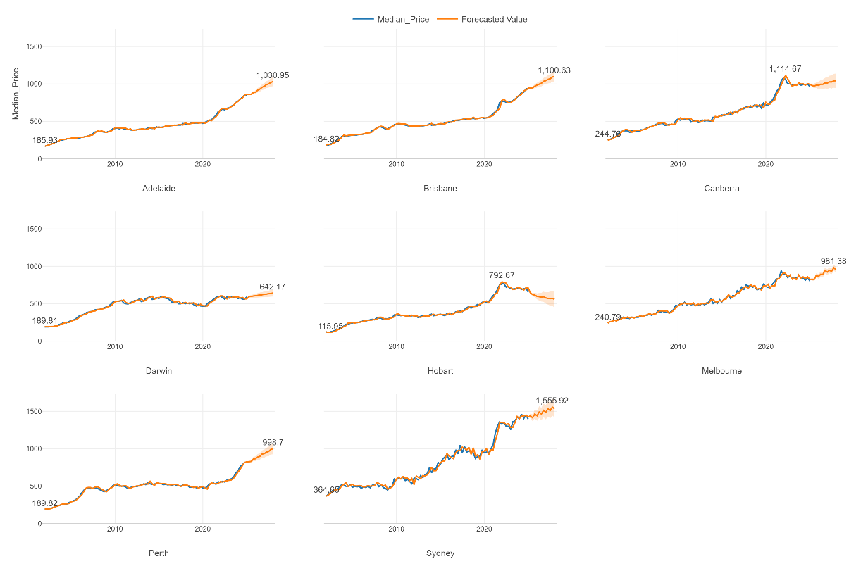
Figure 5: ARIMA city wise forecast

4.2 Random Forest model

Performance of the model was evaluated using the performance evaluation metrics after testing and training the model. This performance is captured in the Table 2 given below. The model fits well with the historical house prices with RMSE value of 25.2338 and reasonably with predicted house prices with RMSE value of 52.3230.
Performance metrics | Training | Testing
R squared | 0.98759154657 | 0.94652351235
RMSE | 25.2338448642 | 52.3230934269

Table 2: Random Forest model evaluation

This performance is further evaluated by generating the actual vs predicted scatter plot as shown in Figure 6. It shows the linear regression between the actual and the predicted housing prices.
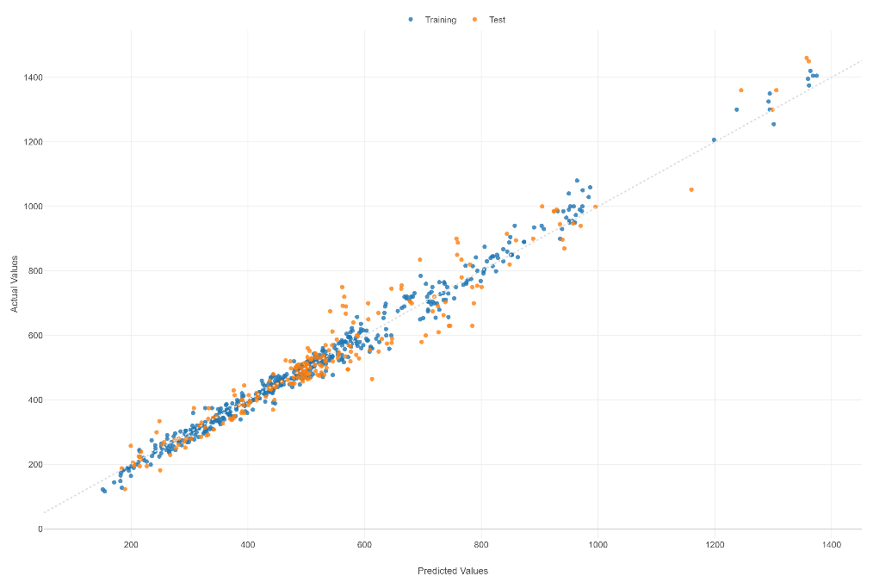
Figure 6: Actual vs predicted scatter plot

Further, partial dependency plots were generated to check how much the predictor variable CPI affects on median house prices. Figure 7 indicate the CPI vs Median Price dependency plot. As shown in the line chart, property prices increase steadily with the increase of CPI showing the strong link between inflation and house prices.
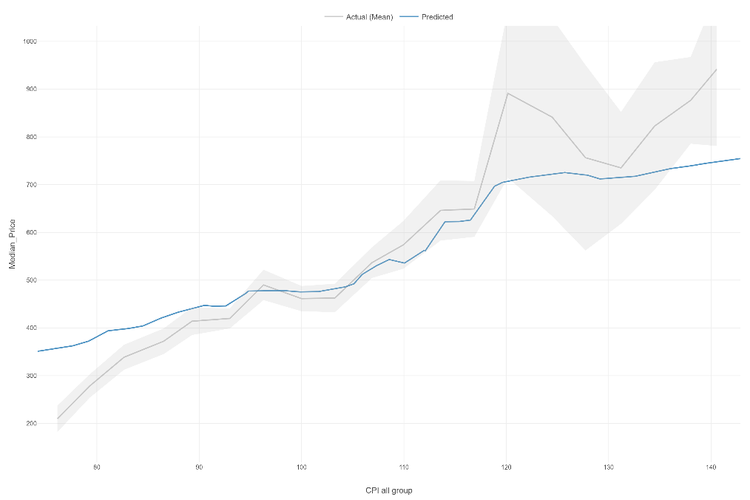
Figure 7: CPI vs Median Price dependency plot

Another partial dependency plot is Median price vs City. As shown in Figure 8, each point represents the predicted property price for that city, and the error bars represent the variation. Sydney has a higher predicted house prices compared to house prices in Adelaide or Hobart.
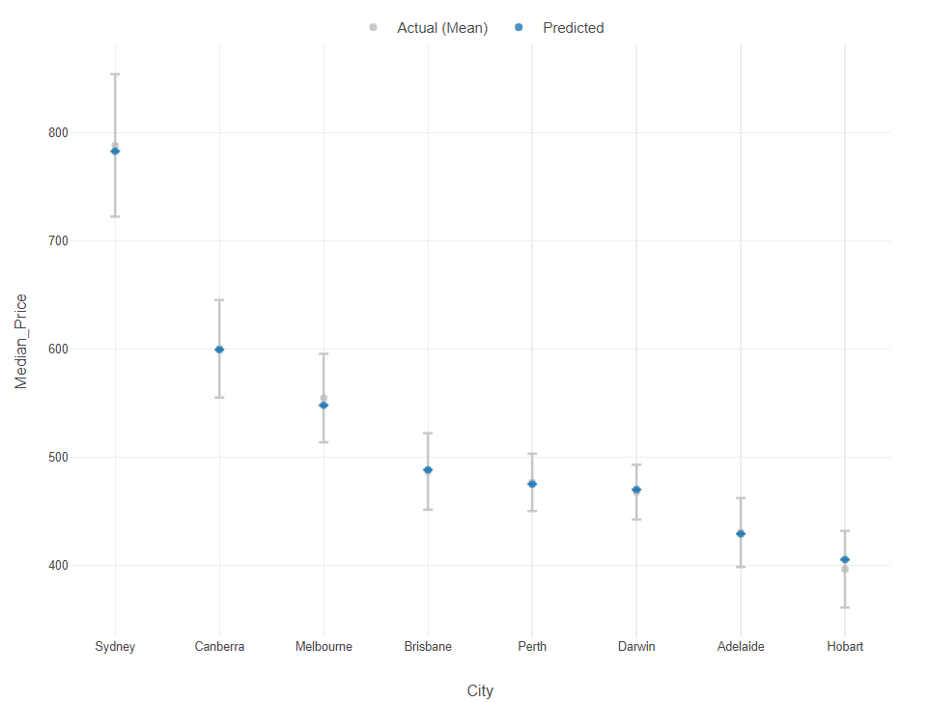
Figure 8: Median price vs City dependency plot

5.0 Recommendations

The past data shows that every year the property prices have tend to increase with the influence of external factors such as population growth, inflation, interest rates etc., creating a necessity of building a model to forecast the future price growth in different cities across Australia for investors, policymakers and property developers to make smart decisions. Use of ARIMA time series forecasts along with Random Forest model have exposed the trends of property prices and the influence of inflation through variables like consumer price index in shaping the market outcomes.
As shown in figure 5, all eight cities are projected to continue price growth over the next three years. Sydney and Canberra remain as the most expensive markets, while Brisbane and Adelaide show significant upward trend over the next three years from a lower base as emerging markets with stronger percentage growth rates. In contrast, Darwin shows a much slower growth rate indicating a deviation in demand comparative to other capital cities. Therefore, it is advisable for policy makers to identify the affordability pressure and existing supply shortages of houses in these cities. These insights were also reinforced by the outcomes of the Random Forest model showing the predictive strength of inflation though CPI. As shown in Figure 8, the model also shows differentiation by city, highlighting that property prices were also shaped by the location due to factors such as migration or population inflows, land availability and economic condition in the relevant city.
Due to the restrictions of time and data, only two predictors were used for Random Forest. While critical factors of inflation such as population growth, interest rates and housing supply were not used. In addition, Random Forest is a less transparent model and is difficult to interpret relationships compared to ARIMA. However, it is effective for handling non-linearities and can be improved with more data.
The combination of the statistical forecasting approach ARIMA and machine learning approach Random Forest, provide both time series trends and non-liner insights that can enhance the decision-making of real estate stakeholders. It also reduces uncertainty in property price forecasts while providing a guidance to stakeholders demonstrating the critical role of data analytics in this research. For future research, it is recommended to expand the dataset and include variables such as interest rates, population growth, income levels which could further improve the model accuracy. This would ensure that stakeholders and policy makers respond proactively to the property market changes.

6.0 Data Ethics and Security

Public datasets such as the ABS data must be handled safely ensuring privacy, legal and ethical considerations without adjusting them to support bias conclusions. Forecasts from the model must be clearly communicated with assumptions and limitations. To maintain the ethical use of data, the data source has been acknowledged under the data processing and managing section and the transparency of the methodology was also maintained throughout the research. Lastly, the insights generated from the model will be used to make informed decisions for stakeholders of real estate industry and not for any misleading purposes. It is advised for any future analytics to enhance the predictive technology to the model must be incorporated under strict governance of data use.

7.0 References

Abelson, P. and Joyeux, R. (2023). Crawford School of Public Policy TTPI Tax and Transfer Policy Institute. [online] Available at: https://crawford.anu.edu.au/sites/default/files/2025-05/Complete%20WP%20Abelson%20Joyeux%20Sep%202023_0.pdf.
Adetunji, A.B., Akande, O.N., Ajala, F.A., Oyewo, O., Akande, Y.F. and Oluwadara, G. (2022). House Price Prediction using Random Forest Machine Learning Technique. Procedia Computer Science, 199, pp.806–813. doi:https://doi.org/10.1016/j.procs.2022.01.100.
Arceo, A., Touchie, M. and O’Brien, W. (2025). Beyond density: Examining overlooked drivers of housing and neighborhood greenhouse gas emissions. Sustainable Cities and Society, 120, p.106131. doi:https://doi.org/10.1016/j.scs.2025.106131.
Batchala, R. (2024) House price predictions using machine learning - ijrpr. Available at: https://ijrpr.com/uploads/V5ISSUE11/IJRPR35785.pdf (Accessed: 21 September 2025).
Hepşen, A. and Vatansever, M. (2011). Forecasting future trends in Dubai housing market by using Box‐Jenkins autoregressive integrated moving average. International Journal of Housing Markets and Analysis, 4(3), pp.210–223. doi:https://doi.org/10.1108/17538271111153004.
Saunders, T. and Tulip, P. (2019). RDP 2019-01: A Model of the Australian Housing Market. Research Discussion Papers, [online] 1(March). Available at: https://www.rba.gov.au/publications/rdp/2019/2019-01/full.html.
Soltani, A. and Chyi Lin Lee (2024). The non-linear dynamics of South Australian regional housing markets: A machine learning approach. Applied geography, 166, pp.103248–103248. doi:https://doi.org/10.1016/j.apgeog.2024.103248.
Temür, A.S., Akgün, M. and Temür, G. (2019). PREDICTING HOUSING SALES IN TURKEY USING ARIMA, LSTM AND HYBRID MODELS. Journal of Business Economics and Management, 20(5), pp.920–938. doi:https://doi.org/10.3846/jbem.2019.10190.
Valadkhani, A., Costello, G. and Ratti, R. (2016). House price cycles in Australia’s four largest capital cities. Economic Analysis and Policy, 52, pp.11–22. doi:https://doi.org/10.1016/j.eap.2016.07.003.
Yanotti , M.B., Kangogo, M., Wright , D., Sarkar, S. and Lyu, F. (2024). House price dynamics and internal migration across Australia | AHURI. [online] www.ahuri.edu.au. Available at: https://www.ahuri.edu.au/research/final-reports/421.

Appendix

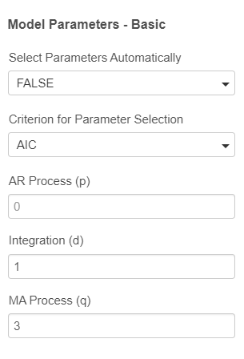
ARIMA model properties
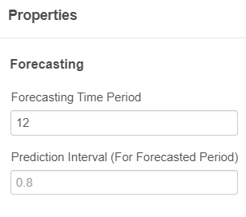

Random Forest model properties
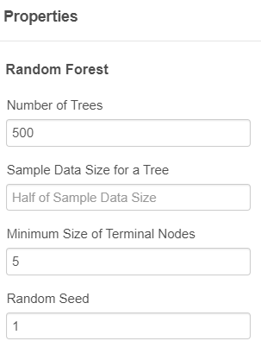
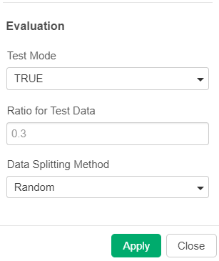

ARIMA city wise forecast
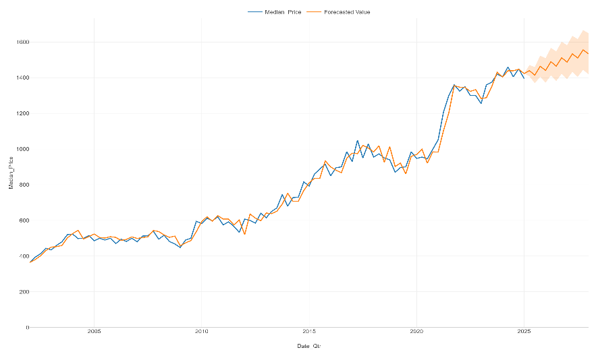
Sydney

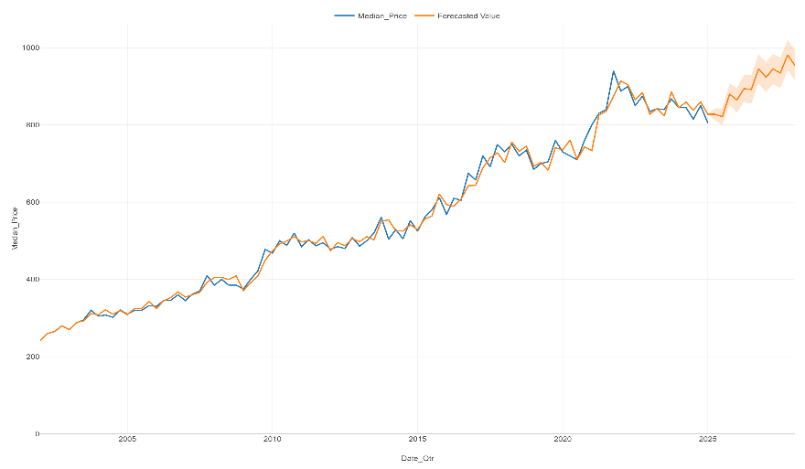
Melbourne

Adelaide
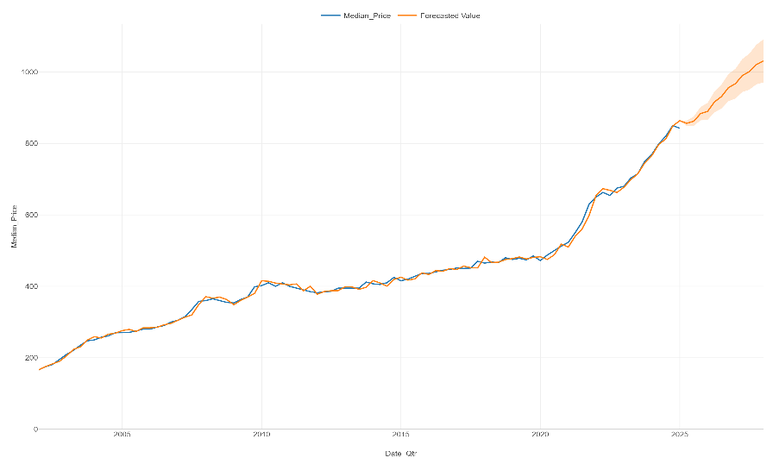

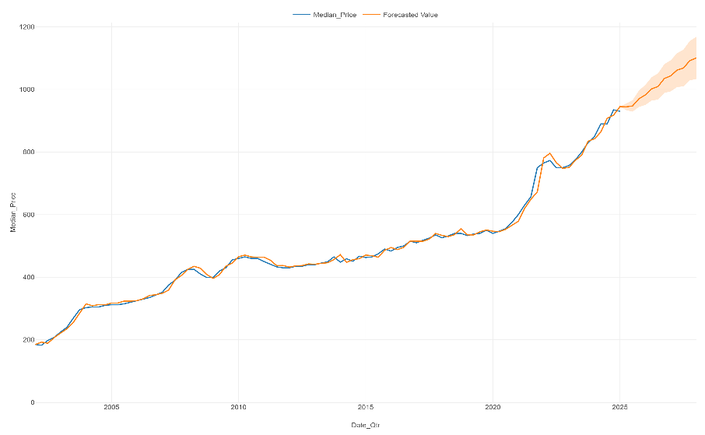
Brisbane

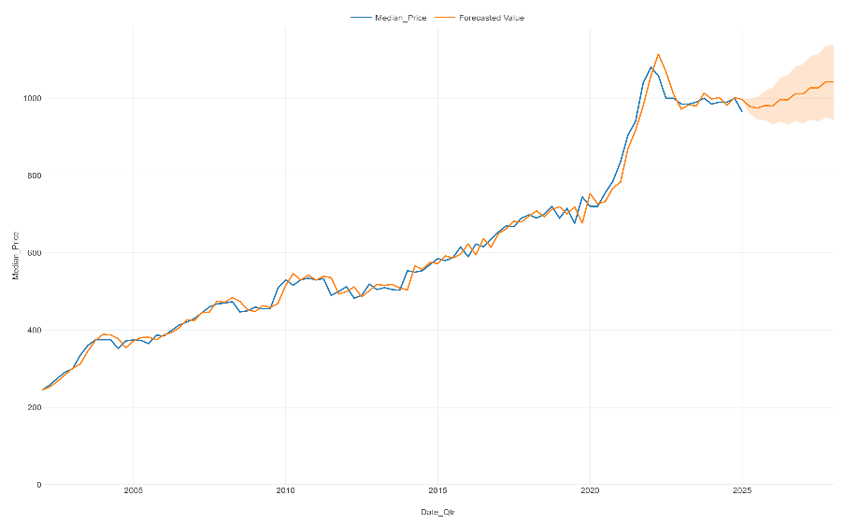
Canberra

Perth
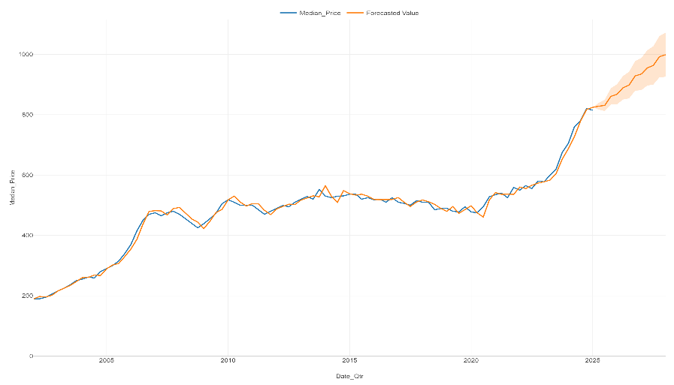

Darwin
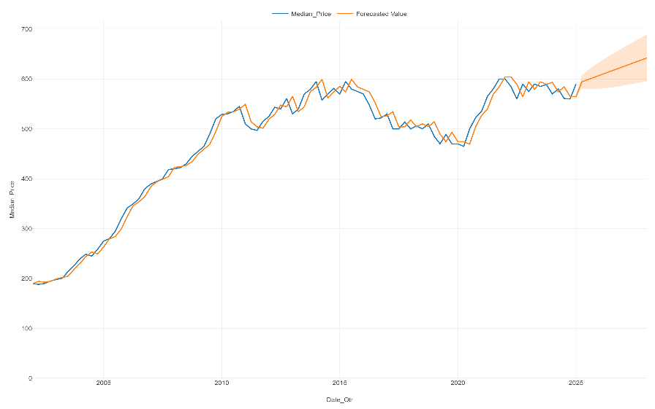

Hobart
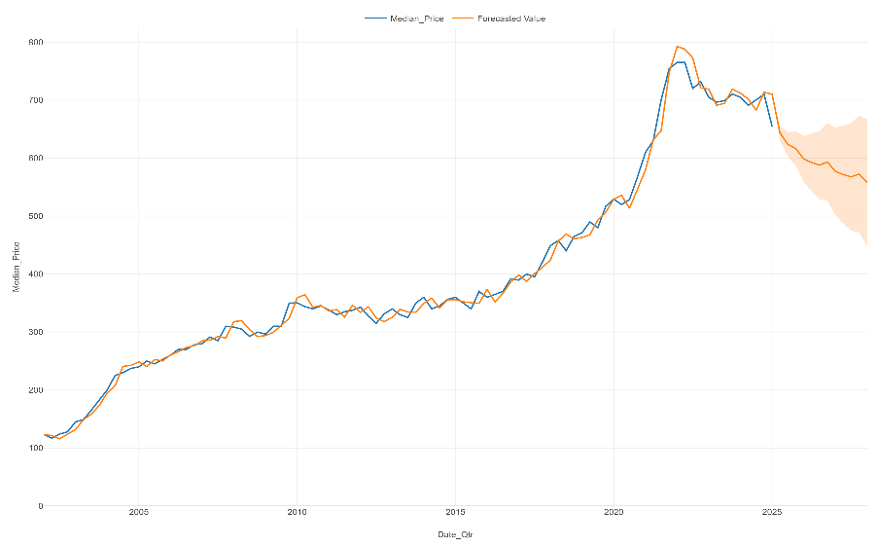

Summary of all cities

